**Meets Specifications**

[](https://media.giphy.com/media/ely3apij36BJhoZ234/giphy.gif)

Dear Student 

You have done exceptionally well in completing this project.

Congratulations for passing the Project. All the best for your future project 

If you find anything I have missed to point out or anything bad in my review, do give me feedback.

Happy Learning and Stay Udacious 

**Exploring the Data**

Student's implementation correctly calculates the following:

* Number of records
* Number of individuals with income >$50,000
* Number of individuals with income <=$50,000
* Percentage of individuals with income > $50,000

All correct.

Another great idea would be to preform some extra exploratory data analysis for the features. Could check out the library Seaborn. For example-

import seaborn as sns

sns.factorplot('income', 'capital-gain', hue='sex', data=data, kind='bar')

**Preparing the Data**

Student correctly implements one-hot encoding for the feature and income data.

**Evaluating Model Performance**

Student correctly calculates the benchmark score of the naive predictor for both accuracy and F1 scores.

The pros and cons or application for each model is provided with reasonable justification why each model was chosen to be explored.

Please list all the references you use while listing out your pros and cons.

note:

To know the pros and cons of a model is really important as this will help you select the best model based on the data-set. and is one of the main questions you are going to face when interviewing for machine learning roles, have a look on the following articles about this.

Comprehensive SAS article on model selection:  
<https://blogs.sas.com/content/subconsciousmusings/2017/04/12/machine-learning-algorithm-use/>

Great Quora thread comparing common ML models:  
<https://www.quora.com/What-are-the-advantages-of-different-classification-algorithms>

And you can also refer this flowchart from Sklearn library:

[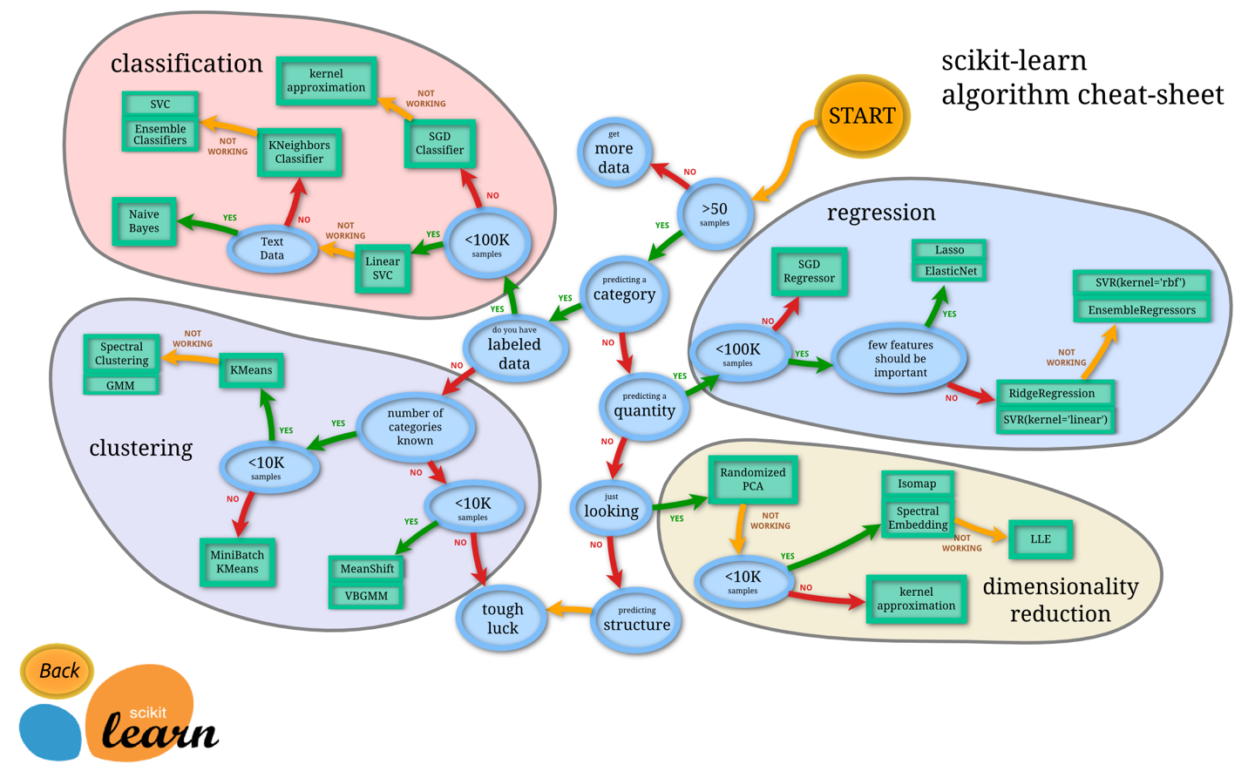](https://udacity-reviews-uploads.s3.us-west-2.amazonaws.com/_attachments/291921/1580227229/ml_map.png)

Student successfully implements a pipeline in code that will train and predict on the supervised learning algorithm given.

Student correctly implements three supervised learning models and produces a performance visualization.

**Improving Results**

Justification is provided for which model appears to be the best to use given computational cost, model performance, and the characteristics of the data.

Student is able to clearly and concisely describe how the optimal model works in layman's terms to someone who is not familiar with machine learning nor has a technical background.

note 1:

When trying to explain an algorithm to a non-technical person is really good to try to use some examples ( like creating a scenario and running step by step of the algorithm) and avoiding the use of technical terms as it can get cumbersome really quickly. when you can't avoid the use of a technical term focus on explaining what this term means.

Another good approach is to use images that makes your explanation rich and easy to understand.

Note 2:

You can find this exigence of trying to explain the algorithm in simple terms redundant but I can assure you that this is  
one of the must-have skills as per my experience (especially on startups) you gonna deal with a person above you that  
has no idea on how it works and being able to explain it in simple terms can make your life at work much easier.

The final model chosen is correctly tuned using grid search with at least one parameter using at least three settings. If the model does not need any parameter tuning it is explicitly stated with reasonable justification.

Great work on implementing the GridSearchCV.

Student reports the accuracy and F1 score of the optimized, unoptimized, models correctly in the table provided. Student compares the final model results to previous results obtained.

**Feature Importance**

Student ranks five features which they believe to be the most relevant for predicting an individual's’ income. Discussion is provided for why these features were chosen.

These are some great features to check out. Very intuitive. However you could have added more, its alright if we have different set of top features.

Student correctly implements a supervised learning model that makes use of the feature_importances_ attribute. Additionally, student discusses the differences or similarities between the features they considered relevant and the reported relevant features.

Student analyzes the final model's performance when only the top 5 features are used and compares this performance to the optimized model from **Question 5**.

Really good work 

Note:

Reducing the number of features on a model is really important to avoid the the Curse of Dimensionality and  
the secret resides on nding the proper number of features that better ts between time and performance.